Stock Mar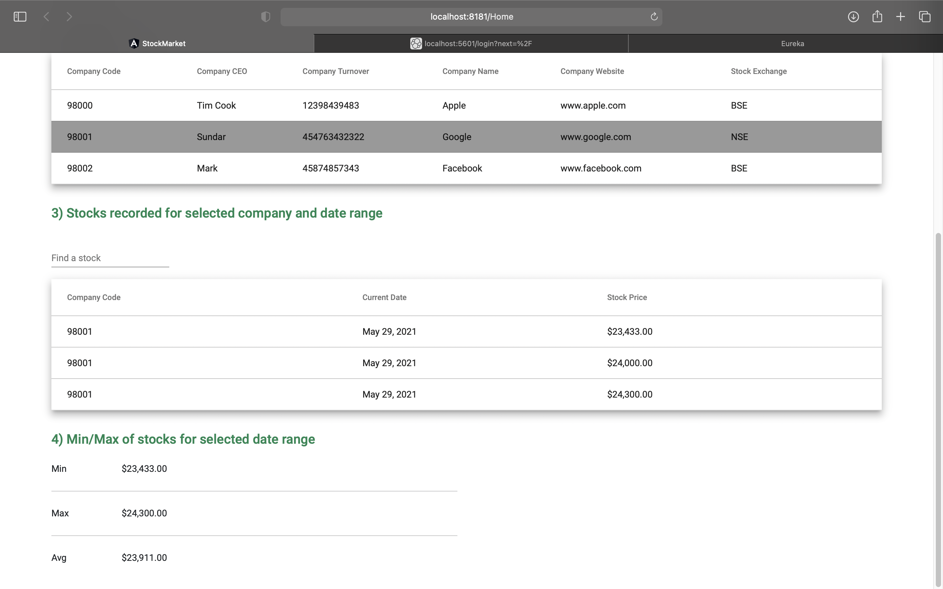ket

1. Home

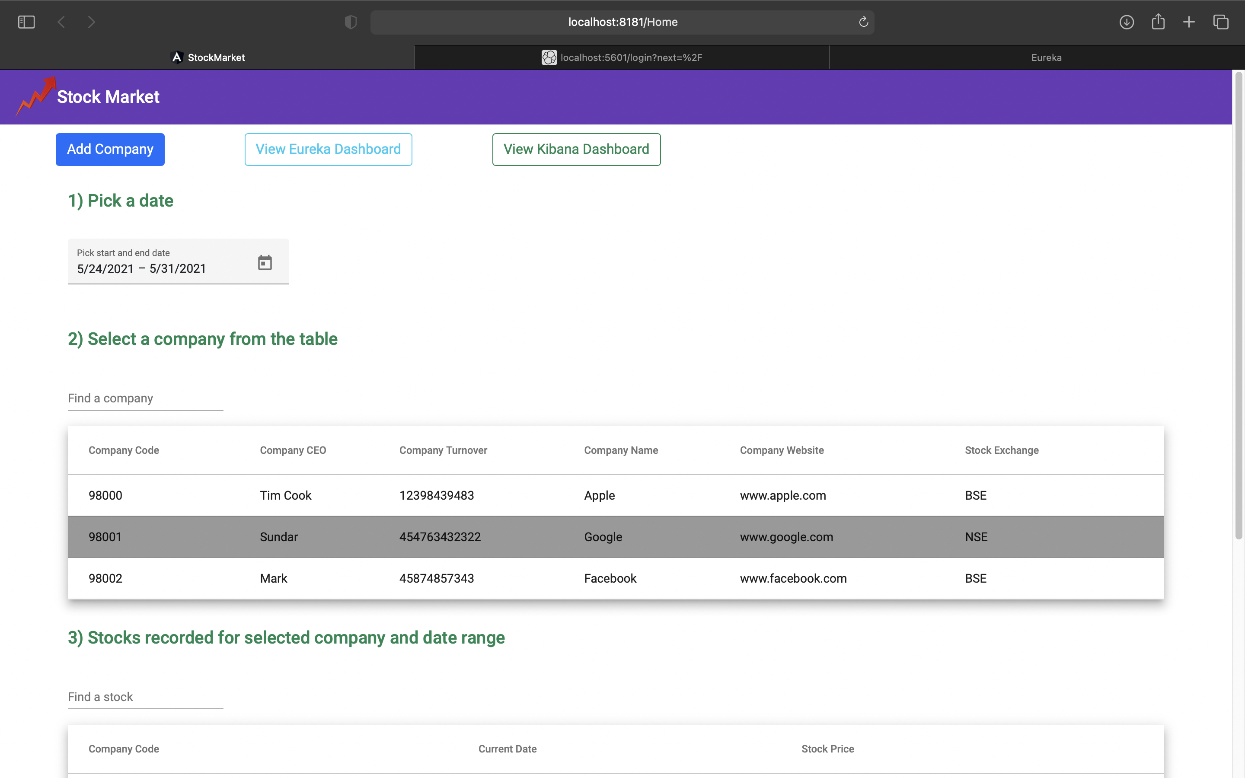

2. Add Company

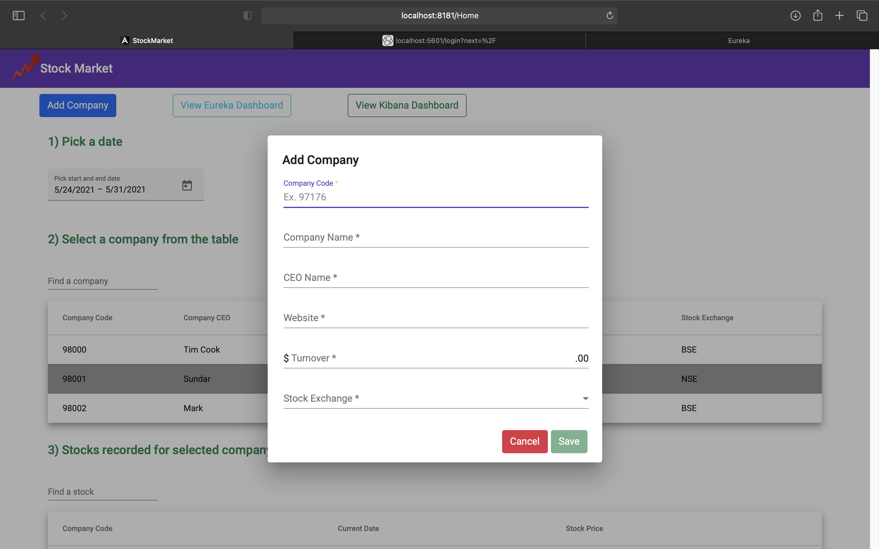

3. Eureka

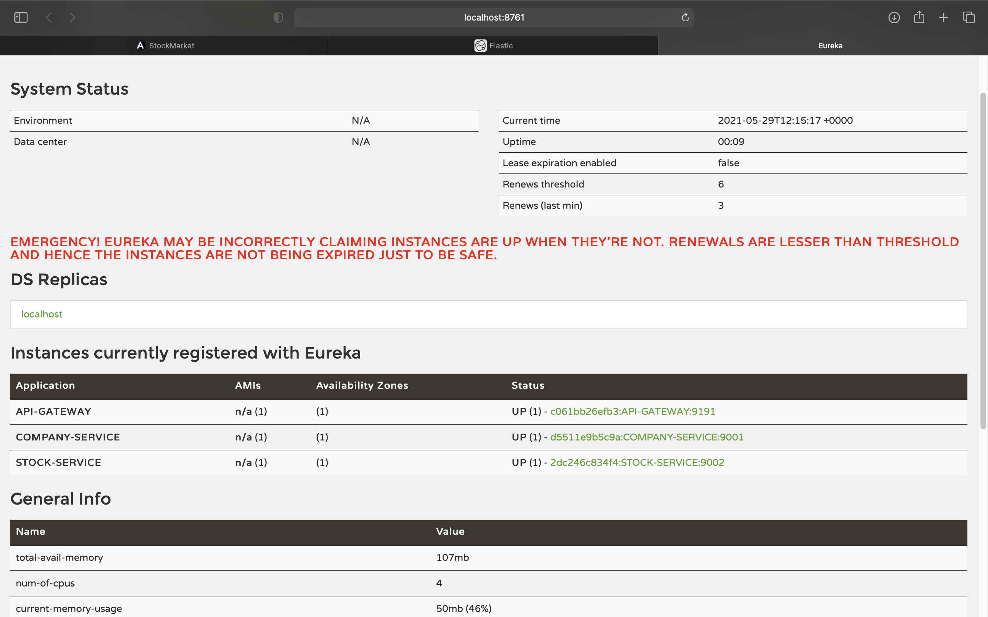

4. Kafka , Logstash ,Elastic, Kibana

Usr: elastic

Pass: change

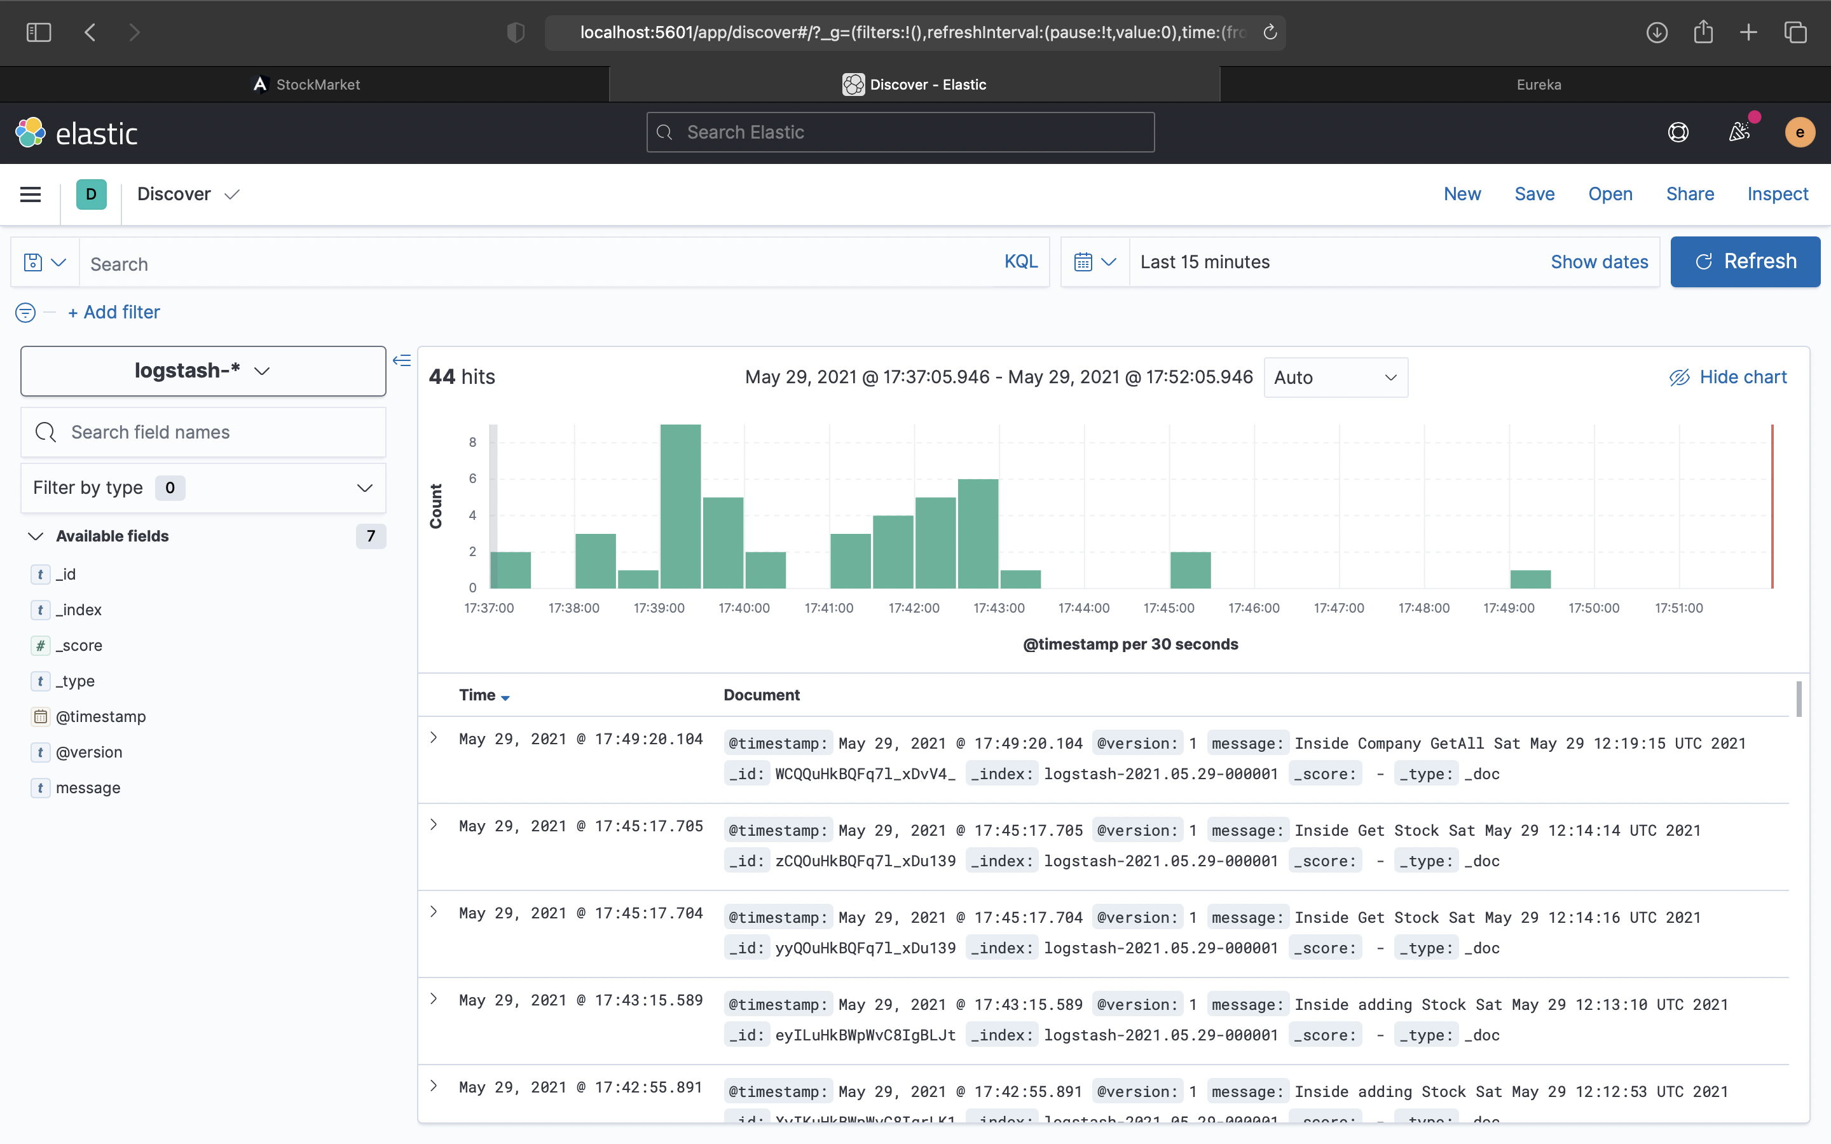

5) Docker Port Info

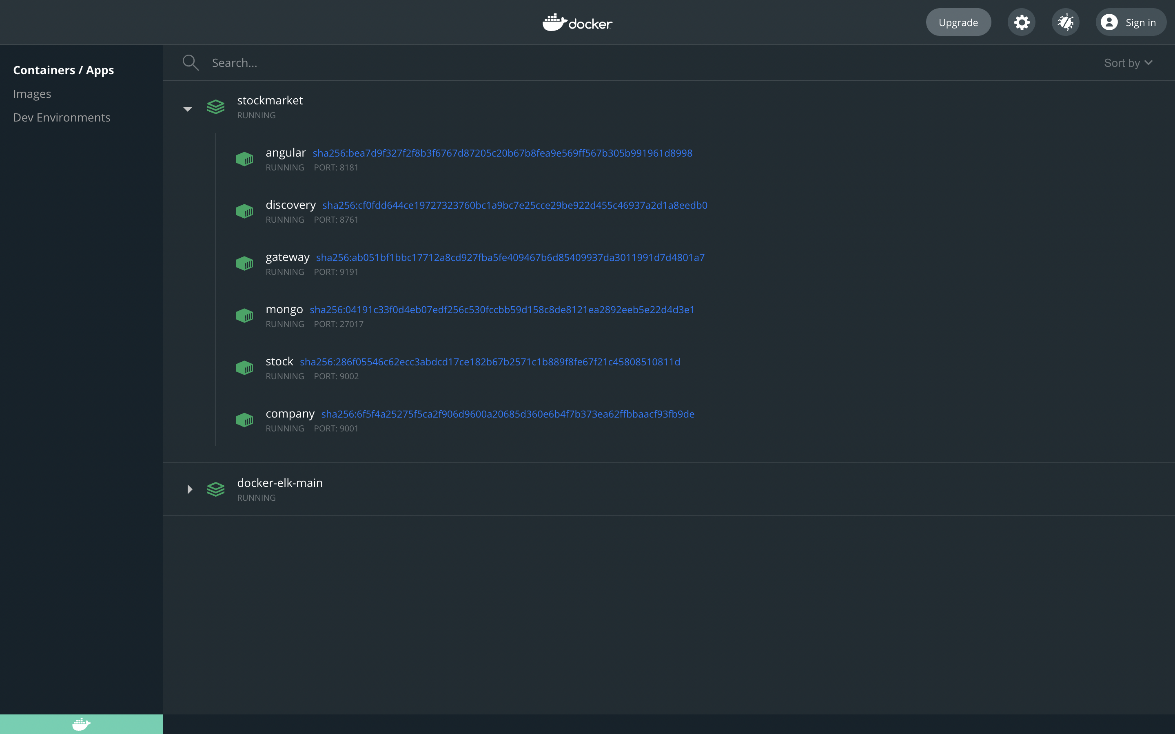

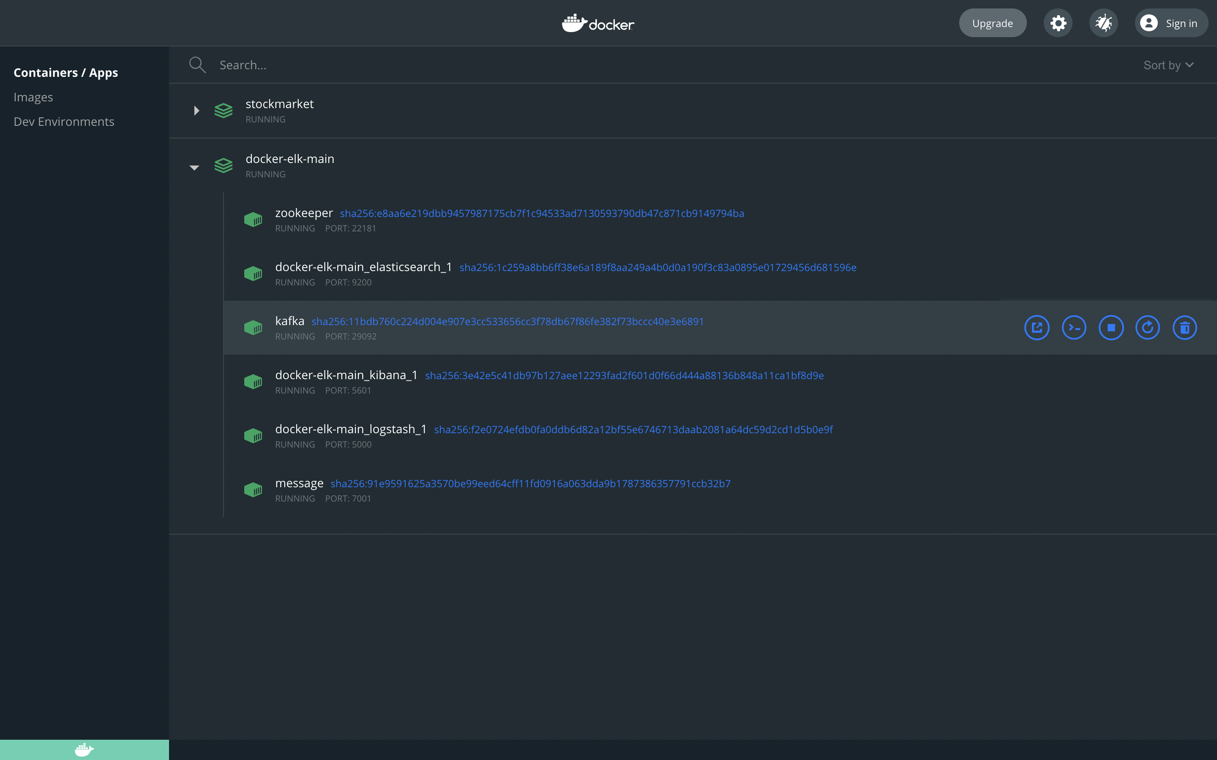

For Space constraint , deleted the build and target.

Angular:

npm install

npm build

Spring projects:

mvn package

1) First Run the docker-compose file from docker-elk-main

2) Run the docker-compose file from StockMarket folder

3) Eureka - [View Eureka Dashboard](http://localhost:8761/)

4) Kibana - [View Kibana Dashboard](http://localhost:5601/)

- username : elastic

- pass: changeme

* **To add stock:**

http://localhost:9191/stock/add/98000

{

"stockPrice":"33000"

}

* **To delete company:**

http://localhost:9001/company/delete/12345

* **Kafka Message:**

<http://localhost:7001/kafka/stock/publish?message=>""

* **Get company:**

<http://localhost:9191/company/info/123>

* **Get All company:**

<http://localhost:9191/company/getall>

* **Get all stocks**

<http://localhost:9191/stock/get/123/2020-05-08/2022-05-08>

* **Add company**

<http://localhost:9191/company/register>

{

"companyCode": "124",

"companyName": "Google",

"companyCEO": "Test",

"companyWebsite": "www.Google.com",

"companyTurnover": "534340.00",

"stockEx": "BSE"

}